**Regional Demand Division**

As part of their reporting, ElectraNet calculates the annual demand for every substation in their system such that demand is not doubled counted. For example, Monash substation is not counted as the demand on that substation is already considered by the North West Bend substation. Once this data is collected, it is then aggregated by the ElectraNet regions, which provides a percentage breakdown of demand in their system. Table 1 provides the overall regional breakdown of demand and Table 2 provides a more detailed view that includes the sub regional breakdown.

**Table 1:** ElectraNet regional breakdown of demand in SA.

|  |  |
| --- | --- |
| ElectraNet Region | SA Demand Percentage |
| Adelaide Metro | 57.65% |
| Eastern Hills | 7.320% |
| Eyre Peninsula | 10.19% |
| Mid North | 9.200% |
| Riverland | 5.680% |
| South East | 8.680% |
| Upper North | 1.280% |

**Table 2:** ElectraNet regional breakdown of demand in SA including relevant sub regions.

|  |  |  |  |
| --- | --- | --- | --- |
| Region | Sub Region | Regional Demand Percentage | Statewide Demand Percentage |
| **Adelaide Metro** |  |  | **57.65%** |
|  | Eastern Suburbs | 16.83% | 9.702% |
|  | Northern Suburbs | 24.21% | 13.96% |
|  | Southern Suburbs | 36.88% | 21.26% |
|  | Western Suburbs | 22.08% | 12.73% |
| **Eastern Hills** |  |  | **7.320%** |
|  | Angas Creek | 12.75% | 0.9333% |
|  | Kanmantoo | 0.80% | 0.0586% |
|  | Mannum | 4.08% | 0.2987% |
|  | Mobilong | 23.91% | 1.750% |
|  | Mt Barker and Mt Barker Sth | 58.46% | 4.279% |
| **Eyre Peninsula** |  |  | **10.19%** |
|  | Port Lincoln | 19.02% | 1.938% |
|  | Stony Point Distribution | 0.05% | 0.0051% |
|  | Whyalla and Whyalla Central | 72.15% | 7.352% |
|  | Wudinna | 5.23% | 0.5329% |
|  | Yadnarie | 3.55% | 0.3617% |
| **Mid North** |  |  | **9.200%** |
|  | Ardrossan West | 4.29% | 0.3947% |
|  | Baroota | 1.29% | 0.1187% |
|  | Brinkworth | 2.30% | 0.2116% |
|  | Clare North | 6.83% | 0.6284% |
|  | Dalrymple | 3.41% | 0.3137% |
|  | Dorrien | 31.93% | 2.938% |
|  | Hummocks | 4.14% | 0.3809% |
|  | Kadina East | 5.19% | 0.4775% |
|  | Port Pirie Network | 20.67% | 1.902% |
|  | Templers | 15.16% | 1.395% |
|  | Waterloo | 4.78% | 0.4398% |
| **Riverland** |  |  | **5.680%** |
|  | Berri | 78.73% | 4.472% |
|  | North West Bend | 21.27% | 1.208% |
| **South East** |  |  | **8.680%** |
|  | Blanche | 36.67% | 3.183% |
|  | Keith | 12.27% | 1.065% |
|  | Kincraig | 12.89% | 1.119% |
|  | Mt Gambier | 21.09% | 1.831% |
|  | Penola West | 6.03% | 0.5234% |
|  | Snuggery Industrial | -16.00% | -1.389% |
|  | Snuggery Rural | 8.30% | 0.7204% |
|  | Tailem Bend | 18.75% | 1.628% |
| **Upper North** |  |  | **1.280%** |
|  | Davenport West | 92.05% | 1.178% |
|  | Leigh Creek South | 3.51% | 0.0449% |
|  | Mt Gunson | 0.41% | 0.0052% |
|  | Neuroodla | 4.03% | 0.0516% |

To transfer this data to the honours regions, several differences need to be considered. As shown in Figure 1 below, the Northern suburbs are partly included in the Mid North honours region. Since an exact split of the demand between the Adelaide Metro honours region and the Mid North honours region is unattainable, demand of the Northern Suburbs is split 50-50 between the regions. This means that half of the Northern suburbs demand will be added to the Mid North honours region.

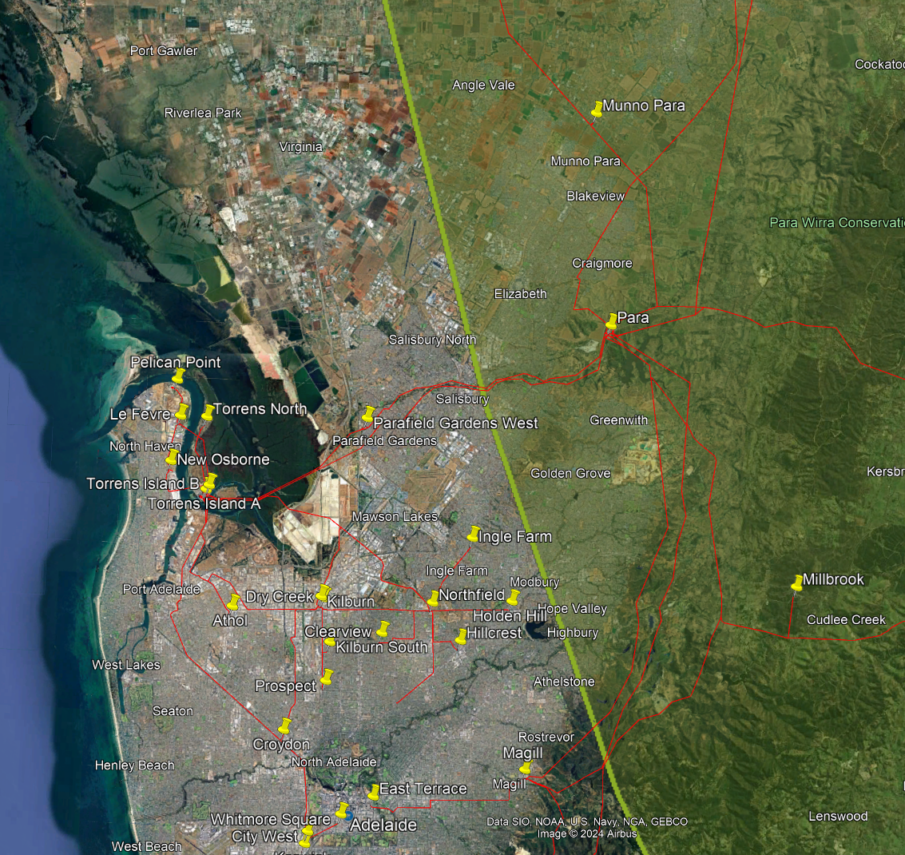

**Figure 1:** Mid North honours regional boundary encompassing approximately half of the Northern suburbs.

The next difference arises in ElectraNet’s Eastern Hills region. Mount Barker substation resides in the Mid North honours region with Mount Barker South substation residing just outside the border as shown in Figure 2 below. Due to their close proximity, Mount Barker South substation is placed in the Mid North honours region. The remainder of ElectraNet’s Eastern Hills region fall within the Mid North honours region.

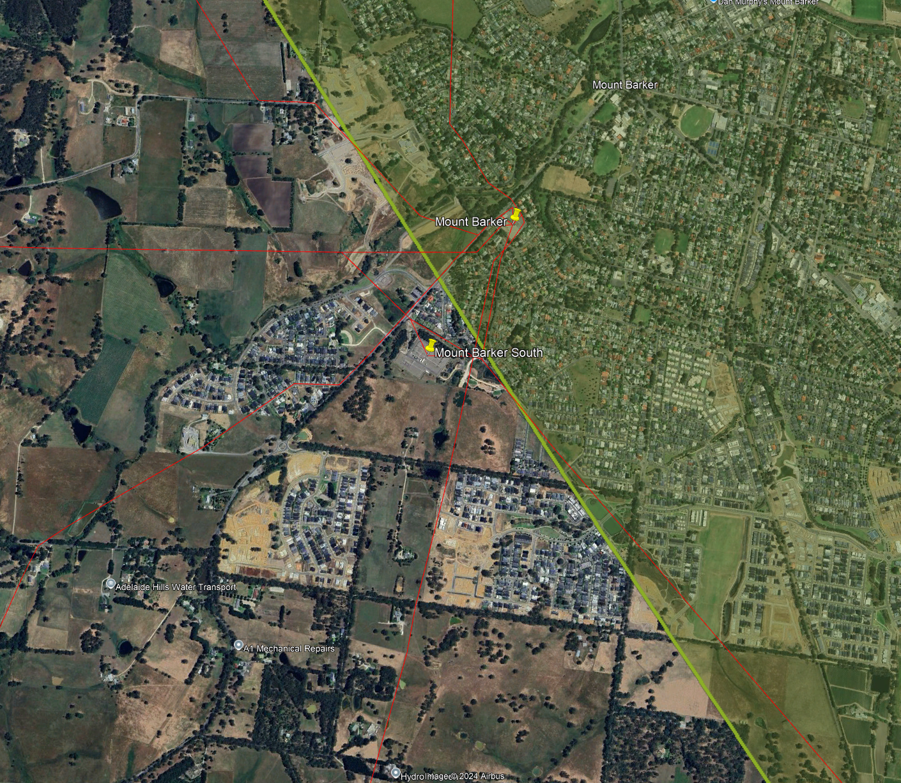

**Figure 2:** Mid North honours regional boundary and the relative locations of Mount Barker and Mount Barker South substations.

Another difference in the honours regional mapping and ElectraNet’s regional mapping occurs in the Eyre Peninsula. In the Eyre Peninsula region, Whyalla and Stony Point fall within the Iron Triangle honours region as shown in Figure 3. Thus, these substations are placed in the Iron Triangle honours region.

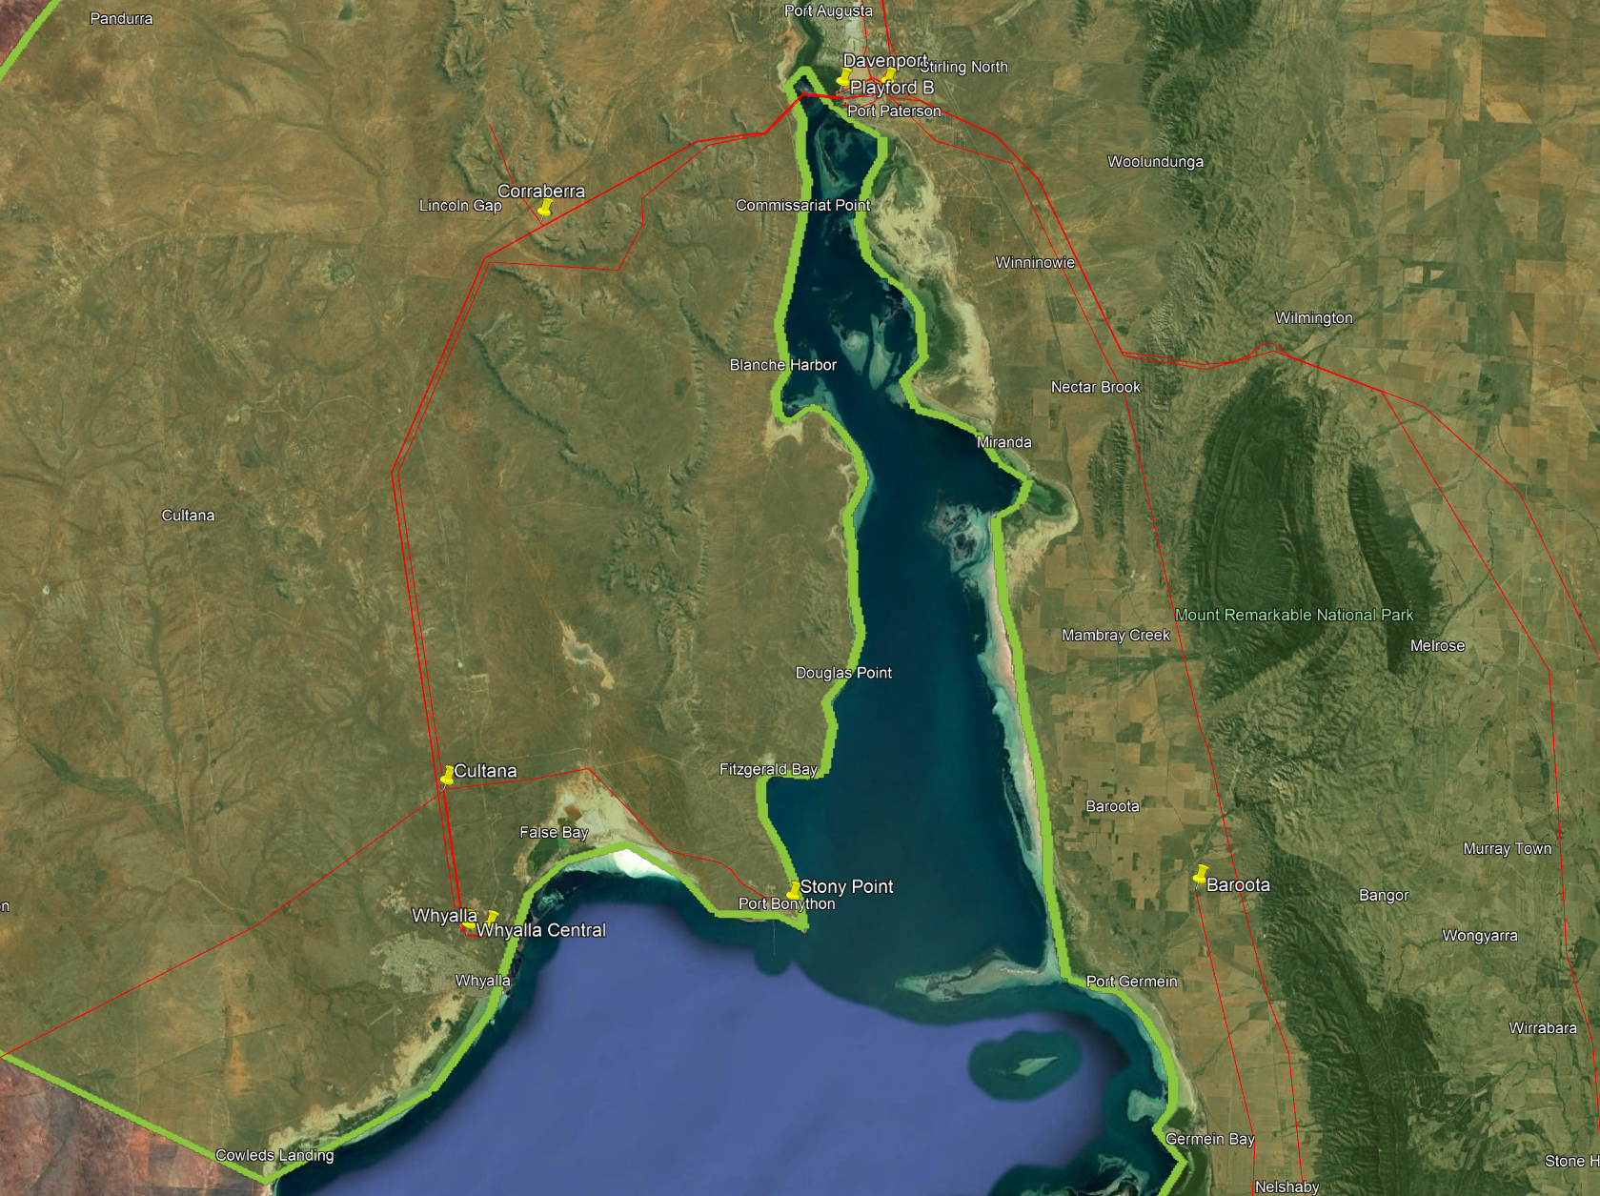

**Figure 3:** Location of Whyalla and Stony Point substation with reference to the Iron Triangle honours region.

The last difference between ElectraNet’s regional splits and the honours regional split occurs in the Iron Triangle honours region. Figure 4 below depicts that all of ElectraNet’s Mid North region fall within the Mid North honours region except for Baroota. Therefore, Baroota is placed in the Iron Triangle honours region.

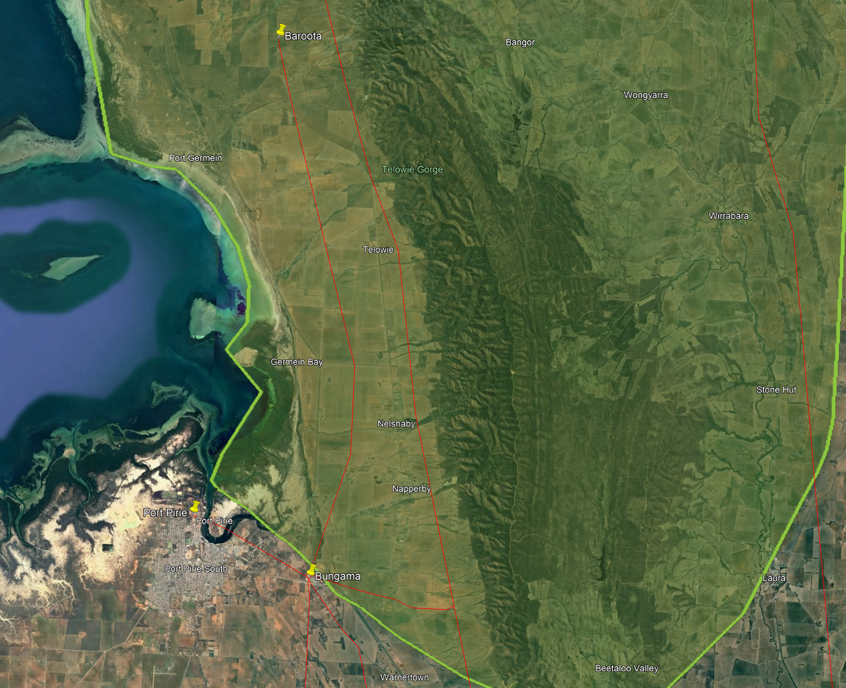

**Figure 4:** Inclusions of Iron Triangle honours region with respect to Baroota substation.

Another aspect that needs to be considered is how the demand breakdown in each region will change over the forecast period. For example, a connection of a large load in the Mid North region would significantly change the current demand breakdown. Due to the uncertainty of the size and location of future load connections, it is assumed that the current regional demand breakdown will approximately be the same in the future, except for one variable, hydrogen loads. AEMO is forecasting hydrogen demand to be responsible for ~25% of the load in SA by 2052. Therefore, the demand breakdown needs to reflect this change over the years.

Currently, there are multiple locations for hydrogen projects as shown in Figure 5, with a majority of the large projects (scale of at least hundreds of MWs) located in either the Eyre Peninsula or Northern SA [171]. Due to the current uncertainty around the feasibility of a hydrogen region and the uncertainty of the hydrogen projects, hydrogen demand is assumed to be split evenly between the Eyre Peninsula honours region and the Iron Triangle honours region.

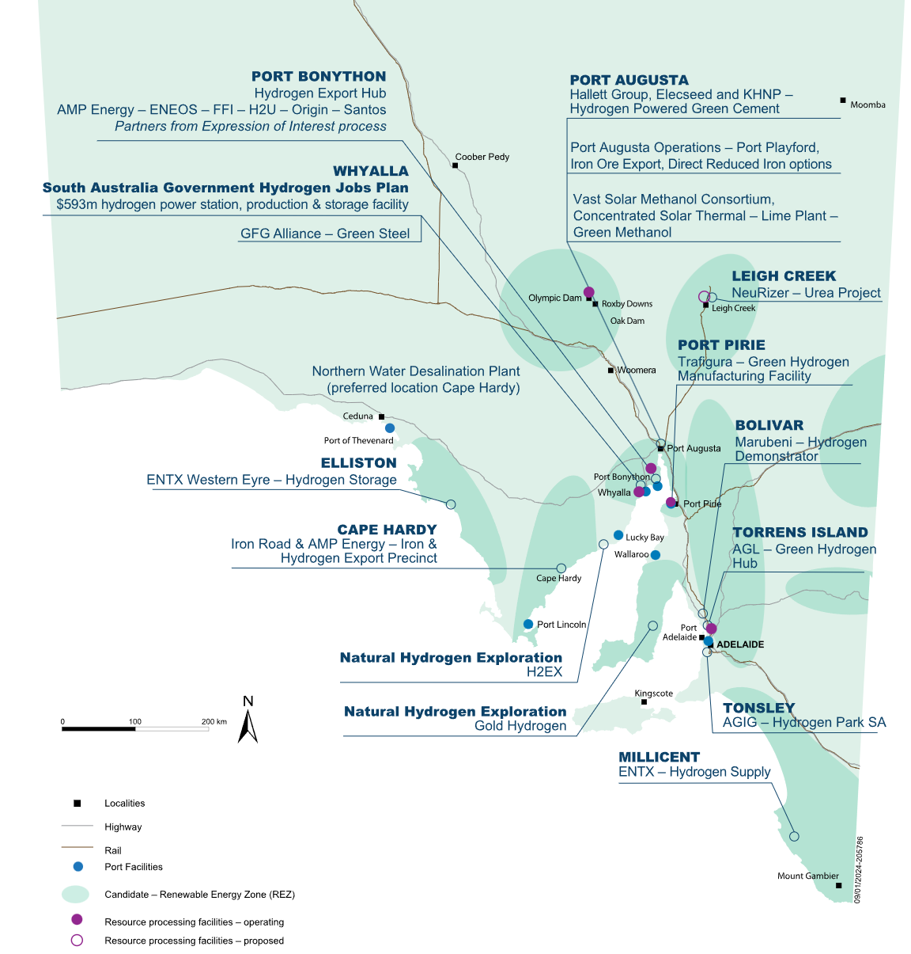

**Figure 5:** Overview of potential hydrogen loads in SA [171].

Since a separate hydrogen trace was created as discussed in Appendix C.2, there is no need to calculate future regional demand splits as it is assumed all regional splits will remain constant and the hydrogen load trace will be split between the Eyre Peninsula honours region and the Iron Triangle honours region. In the event that AEMO adds hydrogen into the overall demand trace, the following mathematical approach can be taken.

To calculate the change in demand over the forecast period of the Eyre Peninsula region and the Northern SA region, it is assumed that currently, no hydrogen load exists in these regions. All future hydrogen demand is expected to be split evenly between these regions. Furthermore, it is assumed that currently, there is negligible hydrogen load in SA, thus, any forecasted hydrogen load only occurs in these said regions. To calculate the change in demand percentage of these regions, Eq. (J.1) is used:

|  |  |
| --- | --- |
| $${Demand}_{FY}={Demand}_{FY-1}+\frac{{∆Hydrogen Demand}_{FY}}{2}$$ | (J.1) |

An example calculation for the Eyre Peninsula honours region is given below for FY26. Note the current Eyre Peninsula ElectraNet regional demand percentage is taken from Table J.2 and the hydrogen demand figures are extracted from Table D.3.

|  |  |
| --- | --- |
| $${Demand}_{Eyre,FY26}={Demand}_{Eyre,FY25}+\frac{{Hydrogen Demand Percentage}_{FY26}}{2}$$ | (J.2) |
| $${Demand}_{Eyre,FY26}=2.833\%+\frac{3.317\%}{2}$$ | (J.3) |
| $${Demand}_{Eyre,FY26}=4.492\%$$ | (J.4) |

The same process is repeated for the Iron Triangle honours region. The next step is to calculate the updated demand percentages for the remaining regions. This is achieved using the following formula:

|  |  |
| --- | --- |
| $${Demand}_{r,FY}={Demand}_{r,FY-1}×\left(\frac{1-{Demand}_{h,FY}}{\sum_{r}{{Demand}_{r,FY-1}}}\right)$$ | (J.5) |

Where $r$ is part of the set of all regions that do not include hydrogen loads and $h$ is the set of regions that include hydrogen loads. The application of this formula is shown for the Adelaide metro region in FY26.

|  |  |
| --- | --- |
| $${Demand}_{Adelaide,FY26}=50.67\%×\left(\frac{1-4.492\%-10.31\%}{50.67\%+0.1018\%+23.38\%+5.680\%+8.68\%}\right)$$ | (J.6) |
| $${Demand}_{Adelaide,FY26}=48.77\%$$ | (J.7) |

This process can then be repeated for each region over every forecasted year.

The final demand breakdown for each honours region is summarised in Table 3 while a detailed version is provided in Table 4.

**Table 3:** Summary of the demand breakdown, not inclusive of hydrogen trace, for each honours region.

|  |  |
| --- | --- |
| Honours Region | SA Demand Percentage |
| Adelaide Metro | 50.67% |
| Eyre Peninsula | 2.833% |
| Iron Triangle | 8.654% |
| Upper North | 0.1018% |
| Mid North | 23.38% |
| Riverland | 5.680% |
| South East | 8.680% |

**Table 4:** Detailed breakdown of the honours regional demand including relevant sub regions.

|  |  |  |  |
| --- | --- | --- | --- |
| Region | Sub Region | Regional Demand Percentage | Statewide Demand Percentage |
| **Adelaide Metro** |  |  | **50.67%** |
|  | Eastern Suburbs | 19.15% | 9.702% |
|  | Northern Suburbs (1/2) | 13.77% | 6.979% |
|  | Southern Suburbs | 41.96% | 21.261% |
|  | Western Suburbs | 25.12% | 12.729% |
| **Eyre Peninsula** |  |  | **2.833%** |
|  | Port Lincoln | 68.42% | 1.938% |
|  | Wudinna | 18.81% | 0.5329% |
|  | Yadnarie | 12.77% | 0.3617% |
| **Iron Triangle** |  |  | **8.654%** |
|  | Stony Point Distribution | 0.0589% | 0.0051% |
|  | Whyalla and Whyalla Central | 84.95% | 7.3521% |
|  | Baroota | 1.371% | 0.1187% |
|  | Davenport West | 13.61% | 1.178% |
| **Upper North** |  |  | **0.1018%** |
|  | Leigh Creek South | 44.15% | 0.0449% |
|  | Mt Gunson | 5.157% | 0.0052% |
|  | Neuroodla | 50.69% | 0.0516% |
| **Mid North** |  |  | **23.38%** |
|  | Northern Suburbs (1/2) | 29.85% | 6.979% |
|  | Ardrossan West | 1.688% | 0.3947% |
|  | Brinkworth | 0.9051% | 0.21% |
|  | Clare North | 2.688% | 0.63% |
|  | Dalrymple | 1.342% | 0.31% |
|  | Dorrien | 12.56% | 2.94% |
|  | Hummocks | 1.629% | 0.38% |
|  | Kadina East | 2.042% | 0.48% |
|  | Port Pirie Network | 8.134% | 1.90% |
|  | Templers | 5.966% | 1.39% |
|  | Waterloo | 1.881% | 0.44% |
|  | Angas Creek | 3.992% | 0.9333% |
|  | Kanmantoo | 0.2505% | 0.0586% |
|  | Mannum | 1.277% | 0.2987% |
|  | Mobilong | 7.486% | 1.7502% |
|  | Mt Barker and Mt Barker Sth | 18.30% | 4.2793% |
| **Riverland** |  |  | **5.680%** |
|  | Berri | 78.73% | 4.472% |
|  | North West Bend | 21.27% | 1.208% |
| **South East** |  |  | **8.680%** |
|  | Blanche | 36.67% | 3.183% |
|  | Keith | 12.27% | 1.065% |
|  | Kincraig | 12.89% | 1.119% |
|  | Mt Gambier | 21.09% | 1.831% |
|  | Penola West | 6.030% | 0.523% |
|  | Snuggery Industrial | -16.00% | -1.389% |
|  | Snuggery Rural | 8.300% | 0.720% |
|  | Tailem Bend | 18.75% | 1.628% |

The comparison of the honours regional division to ElectraNet’s regional split is summarised in Table 5. The main differences are the inclusion of the Iron Triangle region that splits a portion of ElectraNet’s Eyre Peninsula region and Upper North region, and the inclusion of the Eastern Hills region in the Mid North honours region.

**Table 5:** Honours regional mapping compared to ElectraNet’s mapping.

|  |  |
| --- | --- |
| Honours Region | Equivalent ElectraNet Region |
| Adelaide Metro | Adelaide Metro |
| Eyre Peninsula | Eyre Peninsula |
| Iron Triangle | Mixture of Eyre Peninsula and Upper North |
| Upper North | Upper North with the exclusion of Davenport |
| Mid North | Mid North and Eastern Hills |
| Riverland | Riverland |
| South East | South East |